**Visualization of Health Statistics**

I am planning a visualization project on “The Relationship between obesity and diabetes” that will involve creating a data set and then using that data set to make visualization and will be created using a software program called Tableau and Qualtrics as the data collection tool collect and analyze data to show results for making decisions. Diabetes is a serious health condition that can lead to many complications, including obesity, a significant risk, and the two conditions often occur together (Volaco et al.,2018). More than one-third of adults in the United States are obese, and more than one in ten have diabetes.

This project will be used to show the relationship between obesity and diabetes. The tableau software visualizes the data to show how obesity and diabetes are related. To conduct the survey using Qualtrics, questions may include: Do you have a body mass index (BMI) of 30 or higher? Do you have diabetes?, Do you have a family history of diabetes? Are you obese? Do you have any other health conditions? What is your current weight and height? What is your Body Mass Index (BMI)? Below is a line graph visualization showing the relationship between obesity and diabetes. The line shows the trend of the data over time. 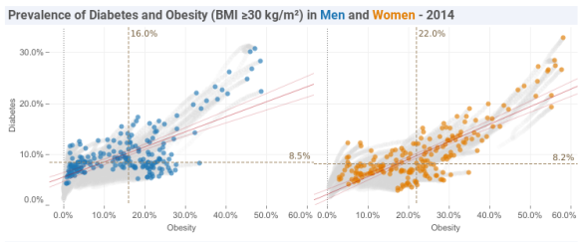

"There is a strong correlation between obesity and diabetes. Obesity is a major risk factor for developing type 2 diabetes. Obesity is responsible for 80-85% of the risk for developing type 2 diabetes."-American Diabetes Association. However, there are some exceptions. This relationship between obesity and diabetes is essential when deciding obesity prevention and treatment. If obesity rates are increasing, then diabetes rates are likely to increase. Therefore, it is necessary to focus on obesity prevention and treatment to reduce the rates of diabetes.

When developing obesity prevention and treatment programs, policymakers and healthcare professionals should consider the strong relationship between obesity and diabetes. Practical programs that reduce obesity rates will likely reduce diabetes rates (Verma et al.,2017). Programs effective in reducing these rates include: Increasing access to healthy food options, exercising, and implementing policies to reduce sugar-sweetened beverages. "Individuals who are obese (BMI of 30 or higher) are two to four times more likely to develop type 2 diabetes than those with a BMI of less than 25."- National Institutes of Health. Treatment for these conditions is essential to seek help if you struggle to manage either condition on your own.

This project would benefit public health officials, as it would help to understand better the relationship between obesity and diabetes, and individuals who are obese or diabetic will realize the importance of managing their weight and blood sugar levels. "The link between obesity and type 2 diabetes is strong, and obesity is thought to be responsible for 80 to 85 percent of the risk for developing this form of diabetes." - Mayo Clinic. This project was created using data from the World Health Organization and the International Diabetes Federation and aims to raise awareness of the importance of maintaining a healthy weight to reduce the risk of developing diabetes.

References

Verma, S., & Hussain, M. E. (2017). Obesity and diabetes: an update. *Diabetes & Metabolic Syndrome: Clinical Research & Reviews*, *11*(1), 73-79. <https://doi.org/10.1016/j.dsx.2016.06.017>

Volaco, A., Cavalcanti, A. M., & Précoma, D. B. (2018). Socioeconomic status: the missing link between obesity and diabetes mellitus? *Current diabetes reviews*, *14*(4), 321-326. <https://doi.org/10.2174/1573399813666170621123227>